What’s the Point of Anaesthesia
Why do we do what we do and why that makes us a big deal

2019

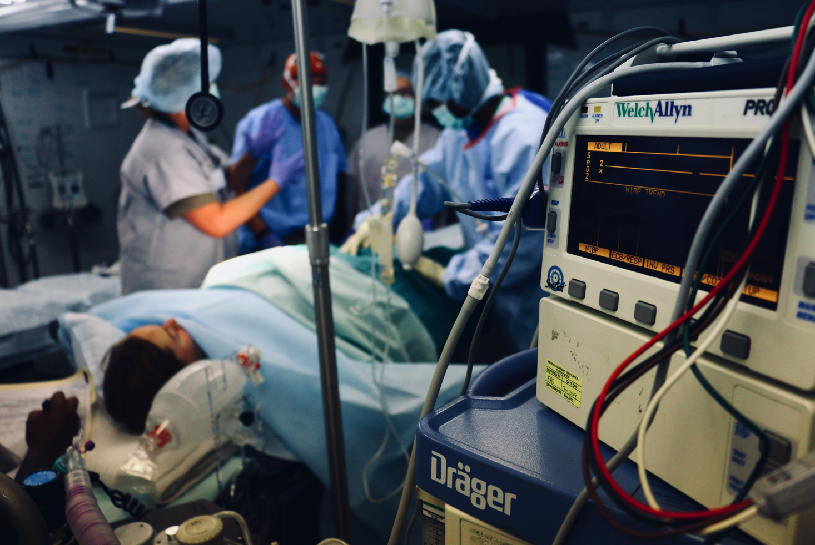

There is probably less known about anaesthesia than most other medical specialties. There are many reasons for this. Anaesthesia is quite a new medical specialty. Australia had its first full time anaesthetist in 1909, in 1952 the royal Australasian college of surgeons founded the faculty of anaesthetists and our college of anesthetists only formed in 1992. Not only that there’s very limited exposure to anaesthesia during your training outside of choosing to do an elective in the specialty. As we are generally ‘contracted’ to assist a surgeon with their operation, the patient has far less contact with us, often being only a 5-10min consult prior to the operation. So it’s no surprise that neither medical professionals nor the general public have a good idea of what we do.

What do we do?

I think the running joke, is that after administering some medications to render you unconscious, we then leave and work on our many other pursuits… crosswords, Sudoku, share trading…

The goal of anaesthesia is to facilitate the surgery with
minimal physiological and psychological impact to the patient.

People often mention the Triad of Anaesthesia – Analgesia, Hypnosis/sedation and muscle paralysis. I think of this as a combination of the patient’s needs and the surgeons needs. If you were a patient, you would want to be pain free (analgesia) and unaware of the surgery (hypnosis). The surgeon however really just needs the patient to be relatively still (paralysis) to enable them to do an effective operation.

Our job is to enable this to occur. We have great medications that render a patient deeply unconscious, pain free and still. But these medications have very serious and potentially lethal consequences. For example propofol is a very effective hypnotic, but it also decreases heart function and causes vasodilation leading to hypotension. So our job is to fix that. Opioids are powerful analgesics, but also suppress respiratory function to the point of apnoea, so we must assist ventilation and oxygenation. Muscle paralysis agents are great for keeping muscles still and relaxed for the surgeon, but this also paralyses the diaphragm ceasing respiration and very rarely can cause anaphylaxis.

The very medications we use to achieve the triad of anaesthesia, also cause severe consequences to human physiology. Our job is to manage these consequences.

But drugs aren’t the only issue! Surgery is a vast spectrum of procedures as minor as a small mole excision to heart and lung transplant. There is a vast range of surgical actions and complications that we have to constantly be ready for. A procedure may have blood loss as an expected consequence (Liver resection, emergency aortic aneurysm repair) or an unexpected complication (laceration of subclavian vein in a clavicle repair). Or occasionally surgical actions may cause a profound vagal response (squint repair, pneumoperitoneum), operations near the lung may lead to a tension pneumothorax or electrolyte imbalance in a patient with cardiac dysfunction may lead to ventricular tachycardia or other arrhythmias.

Our role is to plan, predict, monitor and ultimately manage and solve these complications often while the surgery is progressing.

Patients

Our patients can have a vast range of medical disorders and varying degrees of functional capacity. If you can imagine the many potential problems that can occur due to the complex combinations of medications and the complexity of each operation – this is made immensely more complex depending on the health of the patient.

The comparison between a young healthy patient who may have expected blood loss from a caesarean section can be far more challenging if they simultaneously have a congenital bleeding disorder or refuse blood products.

Our Scope of Practice

It is logical to expect that the skills you practice every day are the skills you will be proficient at. So these daily ‘rituals’ become the base for our expertise and interests in the health care system

- We lead resuscitation teams
- We specialize in acute and chronic pain management
- We are involved in research
- We are active in hospital committees
- We are very useful specialists in all manner of foreign aid
- We teach and pass on these skills in many different settings to many different levels of students and doctors

Why is this the best specialty for me?

When I was a junior surgical doctor, I was on the ward taking care of some very unwell patients. On this particular day, every few hours I would have to make an emergency call when one of my patients would deteriorate. This was an incredibly stressful experience for me. I did not have the knowledge or skills to help my patients and this was terrifying. Fortunately the anaesthetist who arrived to help seemed incredibly calm. It really seemed that nothing about this situation was stressful, and they steadily assigned tasks to stabilise my patient. This was a pivotal moment. I wanted to be that person. I wanted to feel in control of a situation that seemed so dire. I wanted to learn and experience whatever this anaesthetist had learned and experienced to enable me to be able to help those sick patients.

Anaesthesia is one of the few occupations that the time from action to disaster is quite short. For most other careers and medical specialties, by the time you do an action, prescribe a medication and perform a procedure…. If a mistake is made, there is substantial time to correct this. But anaesthesia is different. After giving a paralytic agent you only have a few minutes to oxygenate the patient before they could die of hypoxaemia. If a patient suffers anaphylaxis, you only have a few minutes to correctly diagnosis and treat before the patient suffers cardiovascular collapse.

This all sounds like anaesthesia must be a very stressful profession, and I confess it is at times. But fortunately our system of rigorous training, the hospitals’ safety policies, the incredible medications and equipment at our disposal means that anaesthesia is incredibly safe. It is about 10x safer to have an anaesthetic than to drive a car for a year.

So if you don’t mind the sometimes stressful situations and trust in your training, you will learn how to manage those crises effectively.

Every specialty has certain repetitive elements. For anesthetists this would be iv cannulas and long stable cases where there isn’t much activity. If you enjoy the challenge of cannulas – difficult or easy – and are able to occupy yourself during those longer cases with other important roles in theatre such as teaching or supervising your trainee, anaesthesia could be a great specialty for you.

Often we don't have form long-term professional relationships with our patients. Instead we have to try and gain rapport and comfort patients in the 5 minutes before the operation - during the most stressful part of their surgical journey. If you are able to talk easily with people, and gain their confidence with a natural ease, this is a tremendous advantage in a profession with less (awake) patient contact that most others. I don't mind the lack of patient contact, as it allows me to keep my work and home life separate. I admire those professionals that do form enduring professional connections but it wouldn't suit my personality.

Summary

This is just a small part of a much larger topic about what anaesthesia, but I hope if gives the reader a small insight into this specialty.

If you have anything else you would like to contribute or any other reasons you love working in this field please comment (LINK)

