What do I need to know from the surgeon?

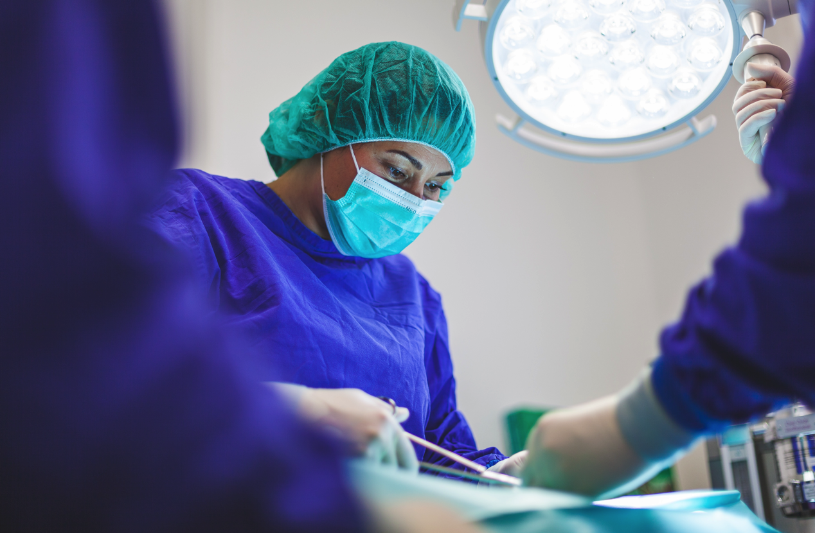

The other side of the blood brain barrier

When I first began anaesthesia training, I found it very daunting and often stressful to have any kind of conversation the surgeon. This was made even more difficult the more senior they were.

Why is it difficult?
There are many reasons for this.
- Talking to any stranger can be challenging let alone one with so much perceived power and authority.
- Medicine is still a very hierarchical field where the risks of upsetting someone ‘above’ you has a certain ‘risk’ to it especially if you are having a discussion to address conflict.
- You might think your questions are silly or not worth asking

Obvious and not so obvious advantages of having a chat with the surgeon
- Information!
- Rapport and communicative state
- Sound knowledgeable
- Specific critical cases

  - Information
This will be obvious for many cases but I never assume. I simply ask the question or make statements if what I expect. Remember the answer may be different for the same case depending on the pathology and the surgeon.

For a routine lap cholecystectomy I might ask:
- Duration
- Position/ are the arms tucked by the side or out
- Expected blood loss
- Antibiotics
- DVT prophylaxis (TEDS/Calf compressors/enoxaparin)
- Specific cases
- Is this patient appropriate?

  - Rapport and communicative state

In most public hospitals it is rare that you would have already met and worked with most surgeons. It is vitally important that you introduce yourself so they have an idea of who you are and your level of experience.

It is also important to realise that the first time you talk to the surgeon should NOT be if you are concerned about a potential crisis. When you are asking the surgeon about something potentially catastrophic you may have considerable difficulty addressing them if you aren’t a naturally assertive person, and there’s a large hierarchical gradient. By having light and general informative conversations at the beginning of the case it makes communication at critical moments far easier!

  - Sound knowledgeable

During my early training years these questions weren’t necessarily intuitive for me to ask. I find that my registrars that know which questions to ask appear more engaged with the nuances of the case and do seem more competent. Over time you will gather a range of subtleties because you have actively sort out answers instead of passively reacting (note memory article).

  - Specific Cases

There are a few cases that have special surgical requirements that will not be apparent unless you have prior experience.

- Avoidance of muscle relaxation
Any case that involves monitoring or repairing a nerve, the surgeon may want to stimulate a nerve and elicit a muscle response. If the patient is paralysed this will not be possible. These cases include thyroidectomies where the recurrently laryngeal nerve needs to be identified and spared and certain plastics and reconstructive cases that involve neural reattachment.

How do you avoid giving muscle paralysis medications when you need a patient to be still?

For many cases that aren’t inside a cavity (laparotomy/laparoscopy, thoracotomy/thoracoscopy), a still patient can be achieved with enough analgesia and hypnotic agent. Note that most LMA spontaneous ventilation anaesthesia has a still patient without giving muscle paralysis.
Cases that need more definitive paralysis
  - Many use a remifentanil infusion at approx. 0.1-0.2mcg/kg/min, remifentanil TCI 2-6ng/ml or more frequent repeated doses of fentanyl.
  - I choose volatile instead of propofol for maintenance of anaesthesia as it provides a small degree of muscle stillness with calcium mediated inhibition.
  - You may have no problem using muscle paralysis as long as it is reversed when the surgeon is stimulating the nerve. This means using a neuromuscular monitor and potentially using a muscle relaxant that has a direct reversal agent like rocuronium or vecuronium.
  - Local or regional anaesthesia is another option is some cases to avoid muscle paralysis (though this might be contraindicated by the surgeon so always check).

- Potential blood loss
I recently had a case involving the radiologist operating on an arterial malformation. It was to be performed in an interventional radiology suite remote from the operating theatre complex. There were many variables that I would need to take into account if the patient were to have bleeding complication and these really can only be planned for with a very detailed conversation.

I wanted to know
  - The likelihood that a significant bleed could occur (should I pause one of the operating theatres in case we need staff and theatre space)
  - The rate of bleeding (can I manage this in the radiology suite or would I have to get theatre space ready)
  - How difficult is the bleeding to correct and how long it will take (how much blood and fluid I need to arrange)
  - I also had to consider what else is happening in the theatre complex and whether a vascular surgeon was available if the radiologist needed assistance.

- Airway surgery
Surgeons generally need good exposure and access to their operative field. Anaesthetists generally need safe and effective control of the airway and breathing (and circulation).
The dilemma with airway surgery (eg vocal cord operations) is that the more control of the airway the anaesthetist has (with a standard endotracheal tube), the less access the surgeon has.

Fortunately there are a number of solutions to this problem.

Closed circuits include smaller ETTs (microlaryngeal tubes – MLT), laser safe tubes (laserflex) and standard tubes. These are more familiar to anaesthetists, and provide more precise control of ventilation and delivery of gases but do compromise surgical access sometimes.

Open circuits include intermitted apnoeic methods and jet ventilation that can be supraglottic (suspension laryngoscope), transtracheal (Hunsaker, Benjet and rigid bronchoscopy) and subglottic (cricothyroid puncture). These are less familiar, would need intravenous anaesthesia but provide great access for the surgery.
Intermittent apnoeic methods involve oxygenating the patient with a mask and then intermittently allowing the surgeon to access the airway. This is generally only appropriate for shorter cases.

- Specific risks
Certain vascular operations also may have a risk of venous air embolism (eg subarachnoid haemorrhage and clavicles fixations as the veins may be stented open by their adherence to bone).
Certain malignancies may have physiologically active substances that pose a threat to the patient. These include phaeochromocytomas and carcinoid tumours.
In general I consider the pathology and try to ask questions that are relevant to its potential impact of the patients physiology.

Is this patient appropriate for surgery?

Very occasionally you will encounter a patient who is very very high risk who may have limited benefit from the surgery. I have gotten into the habit of saying to the surgeon….
‘This is very very high risk for the patient, what is the likely benefit of this operation’
Often the surgery is entirely appropriate but infrequently a patient will arrive without full understanding of the risks and the anaesthetist is often well placed to communicate this and present the risk/benefit situation in a holistic sense.

Summary

Having a detailed conversation with the surgeon is a vital part of the WHO surgical safety checklist and it’s important to go even further to gain specific information as it relates to your particular case.

If you have any thoughts or good or bad experiences, near misses and solid wins please contact us and share your thoughts.

