Optimising Your Memory
Tips and tricks to maximise your potential for this exam

2019

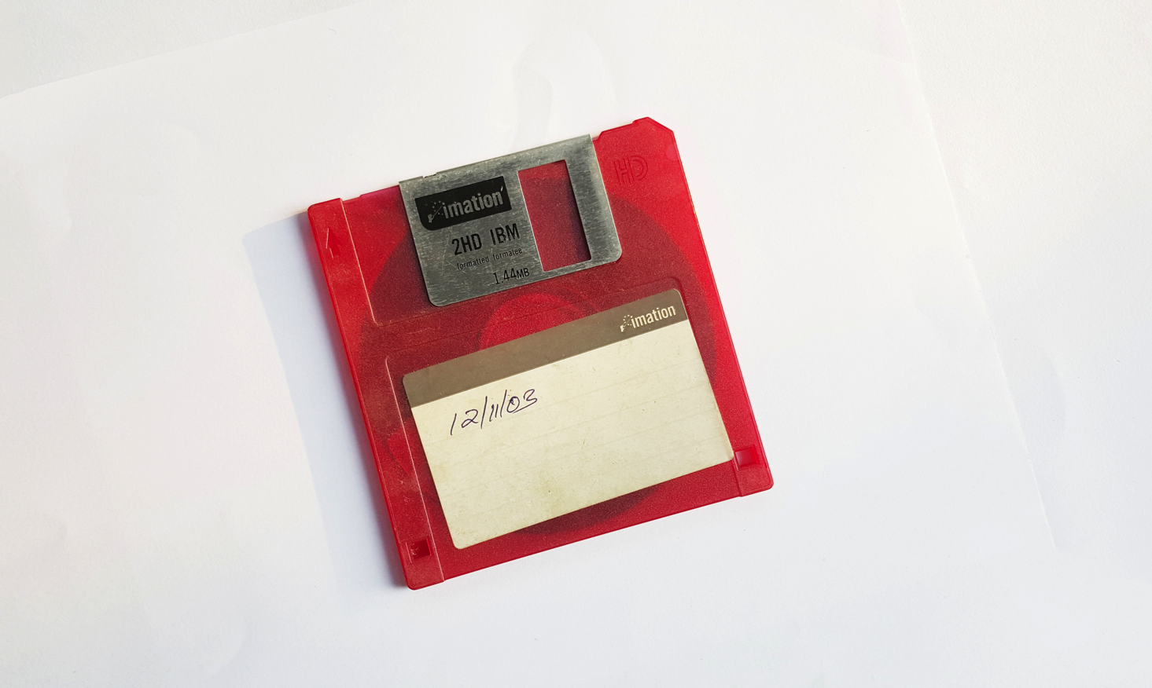

There’s few times in your life where you memory will be stretched to this capacity. Most of us have always been able to cram large quantities of knowledge before every exam we’ve ever done.

This is not that exam!

What is memory?

Memory is the way in which the mind stores and remembers information.
If you look at what is occurring in the brain, memory is related to the function of individual neurons and the stability of connections to other neurons.

How do improve your memory for this exam?

Well, you need to strengthen the neuronal connections so your data is stable.

A few broad principles

- Repetition – mnemonics and active recall
- Immerse yourself
- Learn more to memorise more.
- The importance of a bit of stress/surprise/shock

Repetition

This is an obvious point. If you repeat an action many times it will be hardwired into your brain. Whether you are reciting a poem or that backhand slice in tennis, the more times you do it the stronger that connection will be.

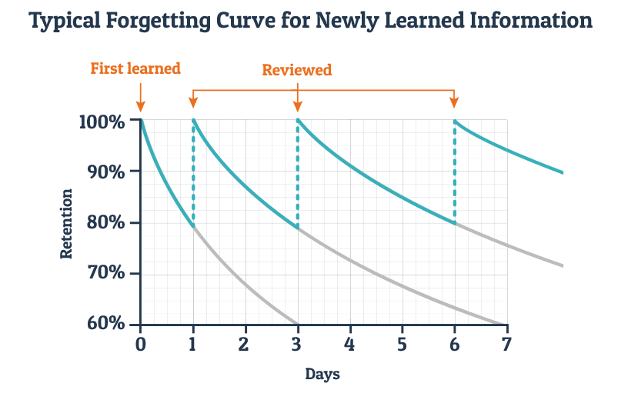

This is Ebbinghaus's forgetting curve for newly learned information.

He also said the best method for increasing memory strength are
- Spaced repetition
- Better memory representation (mnemonic techniques)
- Repetition based on active recall

What does this mean for this exam?

- Spaced repetition
When reviewing learned information, spacing out review of content over time makes items easier to remember rather than repeat studying in a short span of time, also known as massed presentation.

You have to start studying early enough to have enough time for repetition!

The difficult and core topics (eg resp) you will end up going over many many times. So you will naturally memorise many of these learning objectives and SAQs.

- Mnemonic techniques are so incredibly useful no matter how ridiculous they may be.
For example lets memorise the ‘functions of FRC’.

Oxygen store
Buffer to maintain steady arterial PO2
Prevent Atelectasis
Minimise Work of breathing,
Minimise Pulmonary vascular resistance,
Minimise VQ mm

Have a look at these for 30 seconds and try to recall them. How did you do?

Now just memorise these letters BO AW PV. Try again to recall the functions. How did you do?

- Repetition based on active recall

This is difficult coz it is more mentally taxing to recall a sentence of information than to read it. But the entire structure of My Exam Coach is aimed at structuring regular active recall exercises (posting practice exams) through the entire year. Most people start active recall in the last few months before the exam and this is TOO LATE! It is such a waste of valuable time you that you could be increasing memory retention from the start!

Immerse yourself in the content

I approached this exam with a theory that immersion in this exam would be the best way to guarantee a pass mark. Every time in my life I had ever immersed myself in an activity or topic I ended having a very rapid advancement whether it was music or sports or study.

The way I immersed myself in study was to surround myself with the information, in many different formats, active and passive and with different styles to create many opportunities to engage with that information.

This is just another example of strengthening those neural connections that are vital for memory and understanding.

What does this mean for this exam?

The different opportunities for learning information included
- reading about the information (sight - passive)
- writing about the information (touch and sight - active)
- listening to others, podcasts and webinars (auditory – passive) and
- speaking about the information or teaching it (auditory – active).

If I could have written a song or done an interpretive dance about venous admixture I think I would have…

I changed my environment, time and context of study. The old saying that a good study habit is about creating a routine to always study at the same time, at the same desk is simply not true. To make new, multiple and stable neural connections change your study environment!
- Study in the lounge, at the dining table, (probably don't study in the bedroom, that's sacred space for winding down and sleep)
- Study at work, at a café, in the park
- Study when you are most alert and this may time change
- Study with different people

In summary use immersion and variety to increase the neuronal stability throughout the study process.

Learn more to memorise more (Imagery, cases, mnemonics)

This may seem counterintuitive. Surely you have only limited neuronal mass, and you pick and choose what you learn and remember. I’d say that's completely false.

For example, imagine you needed to remember the words dog, cat, pencil, ace of spades, kitchen, cactus, and airplane. If you simply try and remember these words, 5 minutes later most people have adequate recall. But if you were to use more memory to construct a silly story:

IMAGINE a dog and cat playing cards in the kitchen while a plane drops pencils and cacti from above while the dog and cat now frantically run around avoiding the pencillocactile missiles…

I suspect that you would remember that story (and the 6 words) for a strangely long period of time.

What does this mean for this exam?

Don't simply try and memorise facts. Link those facts to other associated facts and stories.

In the functions of FRC example

imagine a person and applying PEEP to preserve the FRC. Oxygen molecules flowing in to create this big ‘store’, someone taking repeat ABGs showing the PaO2 stable, the alveoli expanding from atelectasis, the patient breathing easier, and lung vessels opening to decrease PVR, an image of a VQ scan looking more uniform…..

Or perhaps you want to learn about the LV pressure volume curve. You could simply learn the diagram and the way it shifts. But maybe applying realworld examples such as the effect of cross clamp, adrenaline or a fluid bolus will now contextualize your knowledge to strengthen your existing facts (and neurons).

Learning more about a subject (cases, imagery, mnemonics, etc) strengthens the connections and stability of the neurons you are trying to preserve

Disclaimer: This exam is about learning a reasonable amount of information about many topics and not about specializing in one area at the expense of all the other – eg you could have professorial level knowledge about respiratory with minimal knowledge of everything else and guarantee to fail the exam whereas someone with an average range of knowledge and good frameworks across all topics will pass. So learning more does not mean trying to increase the depth of the knowledge in every topic. It means learning facts to strengthen the important points and selectively increasing depth in the core topics (resp, CVS etc)

The importance of stress

UC Berkeley researchers showed that a relaxed state punctuated by short lived stressors (acute stress) is great for memory and helps boost production of new neurons.

This probably doesn't come as a surprise. Remember the last time you were in a hi-fidelity simulation session or even an exam situation. I find it is so easy to remember the crisis unfold and the learning points whereas I could have been in front of a text book trying to remember the same learning points for hours.

What does this mean for this exam?

I think it’s important to embrace the process of this exam. There are not many experiences in life where you will have such an incredible learning curve and such a grand feeling of achievement. So while I acknowledge there’s a certain level of stress throughout the process, remember that it’s probably a signal that your brain is laying down hundreds of amazing new neuronal connections.

We also want to guide you through that experience with the exam coach program by punctuating your study with practice exams. These are little doses of good stress to help you retain information and lay down those neurons.

Summary

This is obviously a large topic but I hope the suggestions above are useful.

- Repetition – mnemonics and active recall
- Immerse yourself
- Learn more to memorise more.
- The importance of a bit of stress/surprise/shock

Most people in their medical career have already been familiar with amazing feats of memory. So if you have any particularly useful memory tips please contact us at (LINK).

And check out this wiki link for some more mnemonic suggestions

https://en.wikipedia.org/wiki/Mnemonic

