The 4Ms checklist

The crucial things to check prior to induction of anaesthesia
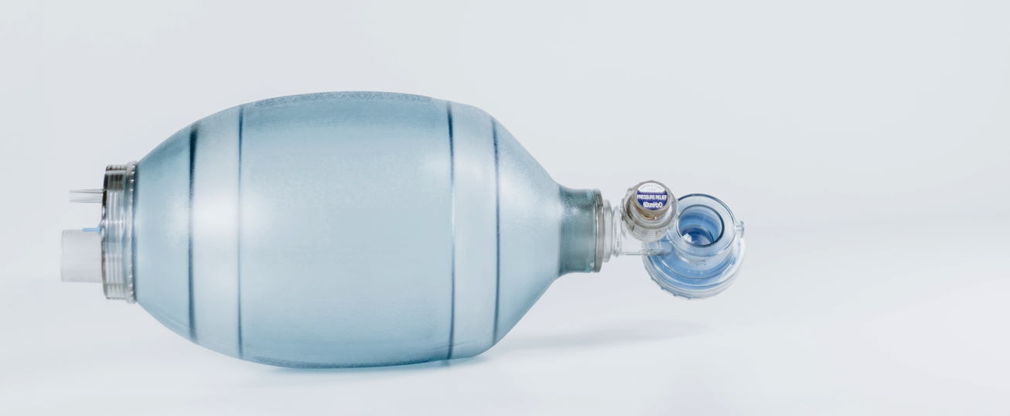

When you first arrive in theatre it is reasonably rare that everything isn’t ready for the fist patient to be induced. Engineering has performed their complicated checks on the machine, and the nurses have a very thorough system by which all the most important equipment and medications for safe anaesthesia have already been checked and stocked.

But every now and again the game changes and safety is not guaranteed. There may be a relatively new assistant who doesn't know all the checks, you may be in a new hospital without rigorous standards, you may need to induce a patient urgently on the ward and the staff there may not know exactly what you require.

I think it is vitally important that you check all the essential equipment and medications yourself at the start of every list. Daily rehearsal of this checklist will almost guarantee that

- You will never proceed with an induction without vital equipment
- You will never stall an urgent induction uncertain if you have everything or not

I have seen both errors occur on a number of occasions and that is what prompted me to put together what I call the 4Ms checklist. It’s just a simple mnemonic to allow you to quickly and safely check that you have all the crucial equipment and meds before inducing anaesthesia.

Disclaimer: Now its important to note that this checklist is not exhaustive and changes depending on the individual situation, the hospital, the patient, support staff and your experience level.
For example if you are a junior anaesthesia trainee, you may include a video laryngoscope in your checklist for any solo inductions. BUT as you gain experience this may not be necessary except for perceived difficult airways.

Anaesthesia checks
The checks are divided into 3 levels. Level 2 and 3 are relevant for us.

- Level 1
  - Done by engineering. Not for anaesthetists, we just check the service label.

- Level 2 (at the beginning of any list)
  - Service label
  - High pressure system
  - Low pressure system
  - Suction
  - Auxillary

- Level 3 (before each new case)
  - Check a changed circuit, vaporizer and all auxillary equipement

The 4Ms Checklist

Machine or BMV

Most machines have an automated checking process now. I simply check that the ‘log’ that shows me the machine and circuit have been checked and there isn’t a large leak. Generally a leak <250ml is safe.

I check that there is a spare self-inflating bag and mask (BMV). If the machine has any issues (or you don't have a machine) the BMV is your best friend. It enables you to deliver positive pressure ventilations with or without oxygen connected. This is all you may have to ventilate an apnoeic patient on the ward.

Open the spare oxygen cylinder. If the gas pressure is <5000kPa it needs to be changed. Do not forget to close the cylinder. If you were to leave it open, it would slowly leak. Also if there was an failure of piped oxygen, the cylinder would then empty and only then would you realise you had no further oxygen.
In the event of failure of pipeline oxygen, you can open the cylinder to give you back up oxygen while you solve the problem.

Finally check your scavenging is adequate.

Medications (SPA drugs)

- Muscle relaxant (esp Suxamethonium)
- Propofol
- Metaraminol (Aramine)
- Adrenaline
- Atropine
- (Fluid)
- (opioids)

Most problems during induction and anaesthesia can solved with the medications above. Firstly, for satisfactory anaesthesia you need a rapid acting hypnotic (propofol) and muscle relaxant (suxamethonium) and depending on the case an opioid as well (fentanyl).

The common problems that occur will be due to propofol causing hypotension in an already sick patient; therefore you will commonly use metaraminol (an easily titrate-able alpha agonist to increase peripheral vascular resistance and BP). In a very unwell peri-arrest patients they may arrest during or after induction so having access to adrenaline seems a reasonable option.

With a slow circulation the medications will have a very long circulation time so to avoid needing repeated flushes having a fluid line is incredibly useful.

Monitoring

- E_{T}CO₂
- Sats
- BP
- ECG

There are a large number of monitors that you could use for anaesthesia. But there’s only a few crucial monitors that will make a tangible difference during an urgent induction.

It is absolutely vital to have oxygen saturations. It will be the first sign that oxygenation is failing and allow you to rapidly diagnose and treat the problem.
It will also give you a indication of heart rate if you do not have ECG available.

E_{T}CO₂ is the gold standard for confirming tracheal intubation and is again mandatory in most hospitals for intubation. It is also a good indicator of cardiac output. With a steady respiratory rate and tidal volume, the E_{T}CO₂ should be steady. A dramatic fall could indicate loss of cardiac output. It also enables you to titrate your ventilation to appropriate PaCO₂ levels when correlated with a arterial blood gas.

Non-invasive or invasive arterial blood pressure monitoring is almost vital in difficult inductions. Hypotension will be one of the most common complications of anaesthesia and rapidly treating severe hypotension is only possible with accurate monitoring.

ECG

Electrocardiographic monitoring displays an accurate heart rate and identifies lethal rhythms, which may be more common in the sick patient.

MABELS

- Masks
- Airway
  - Oropharyngeal airway (Guedels, OPA),
  - nasopharyngeal airway (NPA),
  - laryngeal mask airway (LMA)
- Bougie, Stylet
- ETT (range of sizes)
- Laryngoscope (MAC 3 and 4 blade, check the lights)
  - Video laryngoscope
- Suction

I have used a well-known mnemonic ‘MABELS’ for my airway equipment check.
You need to have all the relevant adjuncts so you have the best chance of oxygenating the patient with at least 1 of the 3 main techniques – BMV, LMA, ETT.

Specific things to mention:
- a range of ETT sizes is required. For the most difficult airways, you may only be able to pass a size 6 ETT.
- Laryngoscope lights often fail so having a spare is wise
- I have never needed to change a size 4 MAC blade to a size 3 so that is always my first option. The size 3 blade often isn’t long enough to insert into the vallecula and dimishes your laryngeal view.
- Suction is the most difficult thing to replace if it is not working. The pharynx will often be soiled with sputum, blood, stomach contents or saliva making intubation near impossible when you can’t visualize the vocal cords. If suction is not working, it is very difficult and slow to problem solve.

SUMMARY

Checklists are a simple and high yield method of enhancing safety. It allows us to offload the straightforward tasks so that we can then focus our cognitive reserves on more complex issues.

Having this checklist and ensuring my trainees are familiar with it has helped me on numerous occasions to rapidly and safely anaesthetise sick patients.

If there’s anything you have found really useful in your anaesthesia equipment preparation or would like to contribute please contact us (link).

